Overview
Valley showcases a snippet of own journey with faith. A journey of hardship and sadness, but of perseverance and love. In spite of doubt, all that can be done is walk with faith. As per the Noise Jam, it will contain visual noise (dithering, compression, contrast) and audio noise (distortion, overdrive, bitcrushing.) At the end of the game, the noise will clear.
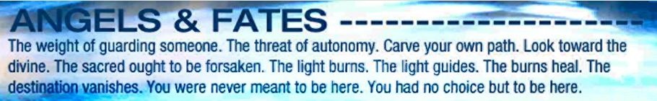
Themes
The flesh always wants to forsake the sacred. The only comfort I've found is with the Lord.
My will always wants to carve my own path. The only times I've found peace so far was in submission.
The Lord always guards you. The weight of guarding everyone is nothing to Him.
I don't know where the destination is, but the weight of trying to find it on my own is lifted.
Mechanics
There is a spirit that is within the player can help light the path forward. There are puzzles involving lighting up certain areas before the player can continue. During some points and landmarks, there will be some dialogue between the player and the spirit.
Pillars
Darkness. Light. Faith. Journey. Temptation.
Story
The player- an anthro cat, is asked by the spirit within him if he's good to continue. The cat responds with yes, he can't stay there forever. The cat and the spirit walk through what looks like a large, dark and desolate valley with landmarks and puzzles along the way, where the cat and spirit have dialogue regarding the cat's past, sins, decisions, and journey of faith. In the end, the cat walks out of the valley, where the sunlight appears and makes all the nose clearer.
Timeline
The jam starts from May 20th at 4 am until June 13th at 4 am. That's 24 days. I started May 13th, making it 31 days. That's a month.

